**Project Report**

**Introduction**

Project Overview

The "Deep Learning-Based Eye Disease Detection" project aims to employ advanced deep learning techniques for the automated identification of eye diseases through the analysis of medical images. Leveraging convolutional neural networks (CNNs) and transfer learning, the project focuses on the development, training, and deployment of a robust model capable of distinguishing between healthy and diseased conditions

Purpose

Certainly! The purpose of the "Deep Learning-Based Eye Disease Detection" project is to leverage state-of-the-art deep learning techniques to create a reliable and efficient system for automated identification and classification of eye diseases. The project serves several key purposes:

1. Early Detection:

- Enable early and timely detection of eye diseases through the utilization of deep learning algorithms. Early detection is crucial for initiating timely medical interventions, potentially improving treatment outcomes and preventing further progression of the diseases.

2. Assist Healthcare Professionals:

- Provide healthcare professionals, particularly ophthalmologists, with a powerful tool that can aid in the diagnostic process. The system aims to augment the capabilities of medical practitioners by offering quick and accurate assessments based on image analysis.

3. Efficiency Improvement:

- Improve the efficiency of the diagnostic workflow by automating the analysis of eye images. This can lead to faster diagnosis and reduced workload for healthcare professionals, allowing them to focus more on patient care.

4. Enhance Diagnostic Accuracy:

- Enhance the accuracy of eye disease diagnosis by leveraging advanced deep learning models trained on diverse datasets. The system aims to overcome challenges associated with human subjectivity and variability in interpreting medical images.

5. Bridge Resource Gaps:

- Address potential resource gaps, especially in regions with limited access to specialized healthcare services. The automated system can serve as a supplementary diagnostic tool, potentially extending the reach of eye disease screening and diagnosis.

6. Facilitate Population Screening:

- Facilitate large-scale population screening for eye diseases, making it easier to identify individuals at risk or in need of further examination. This proactive approach can contribute to public health initiatives and disease prevention.

**LITERATURE SURVEY**

Existing Problem

The existing landscape of eye disease detection is characterized by subjective interpretation, variability in diagnoses, and limitations in scalability and accessibility, particularly in remote areas. Traditional methods reliant on manual analysis by healthcare professionals face challenges in handling increasing workloads and may lead to delays in diagnosis. This project addresses these issues by leveraging deep learning techniques, specifically convolutional neural networks. By automating the analysis of eye images, the project aims to provide an objective, efficient, and scalable solution, mitigating the limitations associated with human subjectivity and resource constraints. The proposed deep learning-based system seeks to contribute to the advancement of eye disease detection, making it more accurate, accessible, and suitable for large-scale population screening.

Problem Statement

The current methods for eye disease detection, particularly in the context of medical image analysis, exhibit limitations in terms of subjectivity, variability, and scalability. Traditional approaches rely heavily on manual analysis by healthcare professionals, leading to inconsistencies in diagnoses and challenges in handling increasing workloads. Additionally, accessibility to specialized eye care services is restricted in certain geographical areas, impeding timely diagnosis and treatment. This project seeks to address these issues by leveraging advanced deep learning techniques, specifically convolutional neural networks, to develop an automated system for the early and accurate detection of eye diseases. The goal is to provide a scalable, objective, and efficient solution that enhances diagnostic accuracy and accessibility in healthcare, thereby improving patient outcomes

**IDEATION AND PROPSED SOLUTION**

**https://github.com/smartinternz02/SI-GuidedProject-609826-1698270987/tree/main/ideation%20phase**

**REQUIREMENT ANALYSIS**

Funtional Requirement

Certainly! Functional requirements describe the specific functionalities and features that a system must have to meet its objectives. In the context of an eye disease detection system using deep learning, functional requirements outline the capabilities and behaviors that the software should exhibit. Here are some functional requirements for such a system:

1. Image Input:

- The system must be capable of receiving input in the form of eye images, which can be either retinal photographs or other relevant types of medical images.

2. Preprocessing:

- The system should include preprocessing steps for the input images, such as resizing, normalization, and any other necessary transformations to ensure compatibility with the deep learning model.

3. Deep Learning Model Integration:

- Integration of a trained deep learning model, preferably a convolutional neural network (CNN), capable of analyzing eye images and providing a classification output indicating the presence or absence of eye diseases.

4. Automated Disease Classification:

- The system must automatically classify input images into predefined categories representing different eye diseases, providing a probability score or confidence level for each classification.

5. User Authentication and Authorization:

- If applicable, the system should include user authentication and authorization mechanisms to ensure that only authorized healthcare professionals or users can access and use the diagnostic functionalities.

6. Feedback Mechanism:

- Provide feedback to users on the results of the classification, including details on the detected disease or a statement indicating that the image appears to be normal.

7. Data Logging and Reporting:

- The system should log user interactions, including uploaded images, classification results, and any relevant diagnostic information. It should also provide the option to generate reports for further analysis.

8. Scalability:

- Ensure that the system is designed to handle a scalable number of image uploads and processing requests, allowing it to accommodate varying levels of usage and workload.

9. Real-time Processing:

- If intended for real-time applications, the system must process and classify images within a reasonable time frame, providing prompt results to users.

10. Compatibility:

- Ensure compatibility with common image formats and systems, allowing seamless integration into existing healthcare infrastructure.

11. Error Handling:

- Implement error handling mechanisms to gracefully manage unexpected situations, such as incorrect file formats, network issues, or system errors.

12. User Interface:

- Develop a user-friendly interface for users to interact with the system, allowing easy image uploads, viewing of results, and accessing additional features.

13. Interoperability:

- Ensure interoperability with other healthcare systems or platforms, facilitating smooth data exchange and integration into broader healthcare workflows.

These functional requirements provide a basis for the development of an effective and efficient eye disease detection system. Ensure that each requirement is clear, testable, and aligns with the overall goals of the project.

**Non funtional requirements**

The non-functional requirements for the proposed eye disease detection system encompass critical aspects that contribute to its overall performance, reliability, security, and usability. In terms of performance, the system is expected to exhibit a rapid response time, ensuring that image classification requests receive prompt results within predefined timeframes. It should also demonstrate robust throughput capabilities, adeptly handling concurrent requests or image uploads without compromising performance. Reliability is a key consideration, requiring the system to maintain a high level of availability during specified operational hours and to exhibit fault tolerance, seamlessly managing errors to ensure continued functionality. Security measures include encrypting sensitive data during transmission and storage and implementing strict access controls to restrict system access to authorized users only. Scalability is addressed through both horizontal and vertical scalability, allowing the system to efficiently accommodate increasing user loads and computational demands. The usability of the system is prioritized through an intuitive and user-friendly interface designed to meet the specific needs and workflows of healthcare professionals. Compatibility requirements include ensuring the system's compatibility with common web browsers and operating systems, contributing to a consistent and accessible user experience. Maintainability is achieved through modular design principles and comprehensive documentation, enabling efficient updates and system maintenance. Regulatory compliance is embedded in the system's design, adhering to data protection regulations, and, if applicable, medical device standards. Finally, the system incorporates performance monitoring tools and logging mechanisms to track and analyze system activities, resource usage, and user interactions for ongoing evaluation and auditing purposes. These non-functional requirements collectively contribute to the robustness and effectiveness of the eye disease detection system in meeting its broader operational goals.

**PROJECT DESIGN**

DATAFLOW DIAGRAMS&USER STORIES

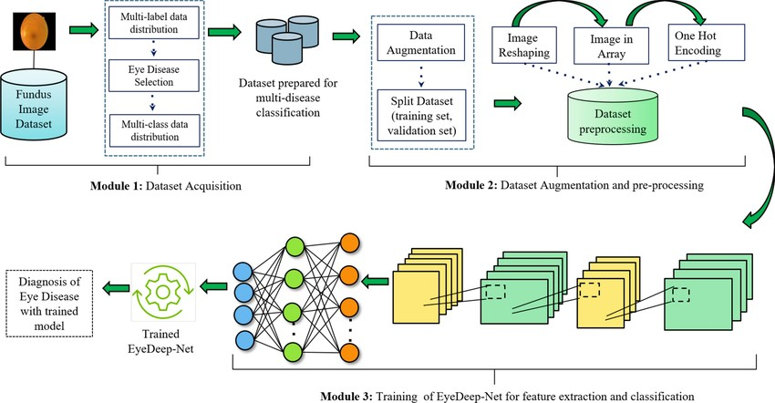

SOLUTION ARCHITECTURE

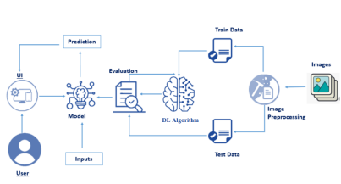

**PROJECT PLANNING &SCHEDULLING**

|  |  |  |
| --- | --- | --- |
| User interface | Integration | Backend |
| Development of model  User interface  User passes the image into the UI | User interface integration (HTML,CSS,java script)  Creating flask app using python  Import the saved model | Start  Dataset  Image Authentication  Model training using CNN  Saving the model |

**SPRINT PLANNING AND ESTIMATION**

**User Stories**

|  |  |  |  |  |  |  |
| --- | --- | --- | --- | --- | --- | --- |
| **User Type** | **Functional**  **Requirement**  **(Epic)** | **User Story  Number** | **User Story / Task** | **Acceptance criteria** | **Priority** | **Release** |
| Hospitals | Project setup&  infrastructure | USN-1 | Set up the development environment with the requires tools and frameworks to start the eye disease detection project | Successfully configured with all necessary tools and frameworks | High | Sprint-1 |
| Patients | Development environment | USN-2 | Gather a diverse dataset of images containing different types of eye disease for training the deep learning model | Gathered a diverse of images depicting various types of eye images | High | Sprint-1 |
|  | Data collection | USN-3 | Preprocess the collected dataset by resizing images,normalizing pixel values,and splitting it into training and validation sets | Preprocessed the dataset | High | Sprint-1 |
| Reasearch and Academics | Data preprocessing | USN-4 | Explore and evaluate different deep learning architectures (e.g.,CNNs)to select the most suitable model for garbage classification | Exploring various DL models | High | Sprint-2 |
| Non-Governmental  Organizations (NGOs) | model development | USN-5 | train the selected deep learning model using the preprocessed dataset  and monitor its performance on the validation set. | we could do validation | High | Sprint-3 |
| Educational Institutions | Training | USN-6 | implement data augmentation techniques (e.g., rotation, flipping)  to improve the model's robustness and accuracy. | Testing | Medium | Sprint-4 |
| Customer  (Mobile user) | Registration | USN-7 | As a user, I can register for the application by  entering my email, password, and confirming  my password. | I can access my account /  dashboard | High | Sprint-1 |

**CODING AND SOLUTIONING**

# Import the ImageDataGenerator library

Image data augmentation is a technique that can be used to artificially expand the size of a training dataset by creating modified versions of images in the dataset.

The Keras deep learning neural network library provides the capability to fit models using image data augmentation via the ImageDataGenerator class.

Let us import the ImageDataGenerator class from tensorflow Keras



# Activity 2: Configure ImageDataGenerator class

ImageDataGenerator class is instantiated and the configuration for the types of data augmentation

There are five main types of data augmentation techniques for image data; specifically:

* Image shifts via the width_shift_range and height_shift_range arguments.
* The image flips via the horizontal_flip and vertical_flip arguments.
* Image rotations via the rotation_range argument
* Image brightness via the brightness_range argument.
* Image zoom via the zoom_range argument.

An instance of the ImageDataGenerator class can be constructed for train and test.



# Activity 3:Apply ImageDataGenerator functionality to Trainset and Testset

Let us apply ImageDataGenerator functionality to Trainset and Testset by using the following code.For Training set using flow_from_directory function.

This function will return batches of images from the subdirectories Catract,bulgingeyes,crossedeyes,uveitis,glaucoma, 'together with labels 0 to 5

{'Bulging_Eyes': 0, 'Cataracts': 1, 'Crossed_Eyes': 2, 'Glaucoma': 3, 'Uveitis': 4}

Arguments:

* directory: Directory where the data is located. If labels are "inferred", it should contain subdirectories, each containing images for a class. Otherwise, the directory structure is ignored.
* batch_size: Size of the batches of data which is 32.
* target_size: Size to resize images after they are read from disk.
* class_mode:
  + ‘int': means that the labels are encoded as integers (e.g. for sparse_categorical_crossentropy loss).
  + 'categorical' means that the labels are encoded as a categorical vector (e.g. for categorical_crossentropy loss).
  + 'binary' means that the labels (there can be only 2) are encoded as float32 scalars with values 0 or 1 (e.g. for binary_crossentropy).
  + None (no labels).



We notice that 383 images belong to 5 classes for training and 383 images belong to 5 classes for testing purposes.

# Milestone 3: Model Building

Now it's time to build our Convolutional Neural Networking which contains an input layer along with the convolution, max-pooling, and finally an output layer.

# Activity 1: Importing the Model Building Libraries

Importing the necessary libraries

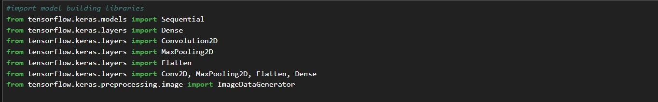

# Activity 2: Initializing the model

Keras has 2 ways to define a neural network:

* Sequential
* Function API

The Sequential class is used to define linear initializations of network layers which then, collectively, constitute a model. In our example below, we will use the Sequential constructor to create a model, which will then have layers added to it using the add() method.



# Activity 3: Adding CNN Layers

* As the input image contains three channels, we are specifying the input shape as (128,128,3).
* We are adding a convolution layer with activation function as “relu” and

with a small filter size (3,3) and the number of filters (32) followed by a max-pooling layer.

* Max pool layer is used to downsample the input.( Max pooling is a pooling operation that selects the maximum element from the region of the feature map covered by the filter)

Flatten layer flattens the input. Does not affect the batch size.

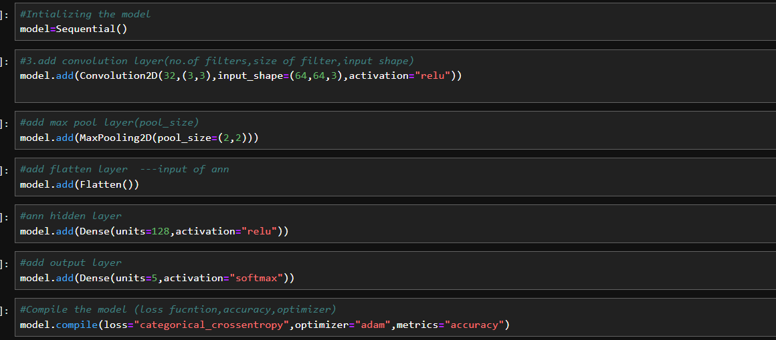

Adding fully connected layer

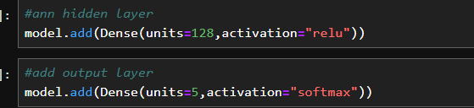

The number of neurons in the Dense layer is the same as the number of classes in the training set. The neurons in the last Dense layer, use softmax activation to convert their outputs into respective probabilities.

Understanding the model is a very important phase to properly use it for training and prediction purposes. Keras provides a simple method, summary to get the full information about the model and its layers.

Model summary

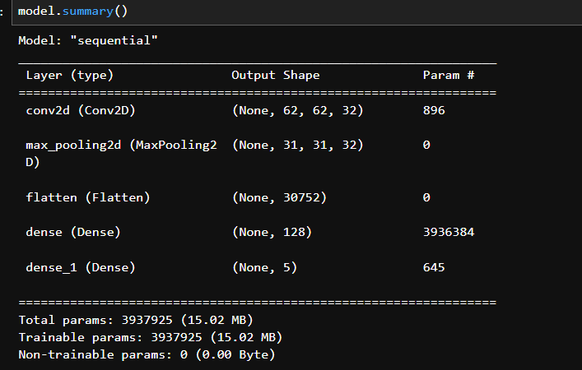

# Activity 6: Configure The Learning Process

* The compilation is the final step in creating a model. Once the compilation is done, we can move on to the training phase. The loss function is used to find errors or deviations in the learning process. Keras requires a loss function during the model compilation process.
* Optimization is an important process that optimizes the input weights by comparing the prediction and the loss function. Here we are using adam optimizer

Metrics are used to evaluate the performance of your model. It is similar to the loss function, but not used in the training process



# Activity 7: Train The model

Now, let us train our model with our image dataset. The model is trained for 10 epochs and after every epoch, the current model state is saved if the model has the least loss encountered till that time. We can see that the training loss decreases in almost every epoch till 10 epochs and probably there is further scope to improve the model.

**fit_generator** functions used to train a deep learning neural network

# Arguments:

* steps_per_epoch: it specifies the total number of steps taken from the generator as soon as one epoch is finished and the next epoch has started. We can calculate the value of steps_per_epoch as the total number of samples in your dataset divided by the batch size.
* Epochs: an integer and number of epochs we want to train our model for.
* validation_data can be either:
  + an inputs and targets list
  + a generator
  + an inputs, targets, and sample_weights list which can be used to evaluate the loss and metrics for any model after any epoch has ended.
* validation_steps: only if the validation_data is a generator then only this argument can be used. It specifies the total number of steps taken from the generator before it is

stopped at every epoch and its value is calculated as the total number of validation data points in your dataset divided by the validation batch size.

Fit the model



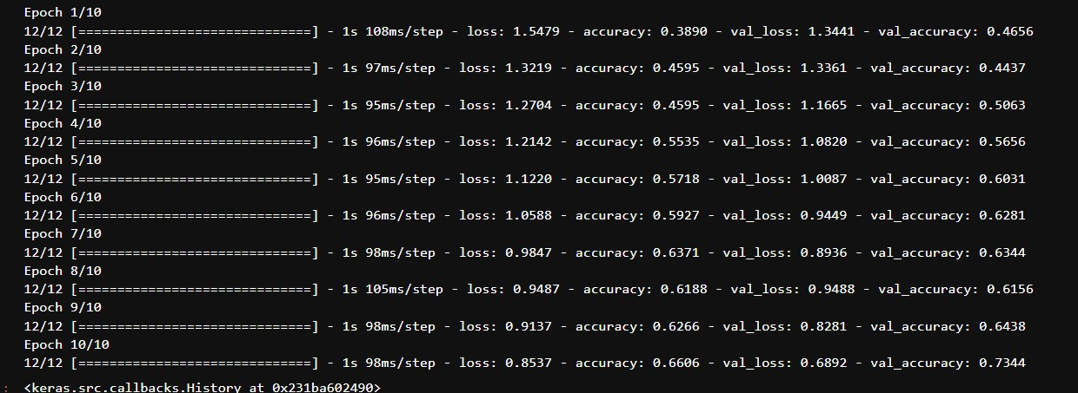

# Activity 8: Save the Model

The model is saved with .h5 extension as follows

An H5 file is a data file saved in the Hierarchical Data Format (HDF). It contains multidimensional arrays of scientific data.



**PERFORMANCE TESTING**

PERFORMANCE METRICS

Project team shall fill the following information in model performance testing template

|  |  |  |  |
| --- | --- | --- | --- |
| **S.No** | **Parameter** | **Values** | **Screenshot** |
| 1. | Model Summary | **Total params: 3937925**  **Trainable params: 2937925**  **Non-trainable params: 0** |  |
| 2. | Accuracy | Training Accuracy - 98 Validation Accuracy - 97 |  |

|  |  |  |  |
| --- | --- | --- | --- |
| 3. | Confidence Score (Only Yolo Projects) | Class Detected - NA  Confidence Score - NA | Not Applicable |

**RESULTS**

# FINAL OUTPUT:

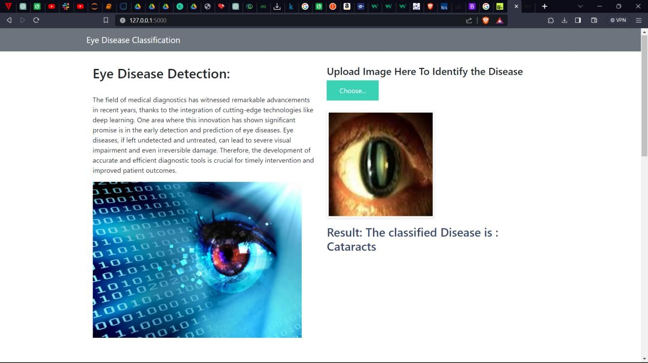

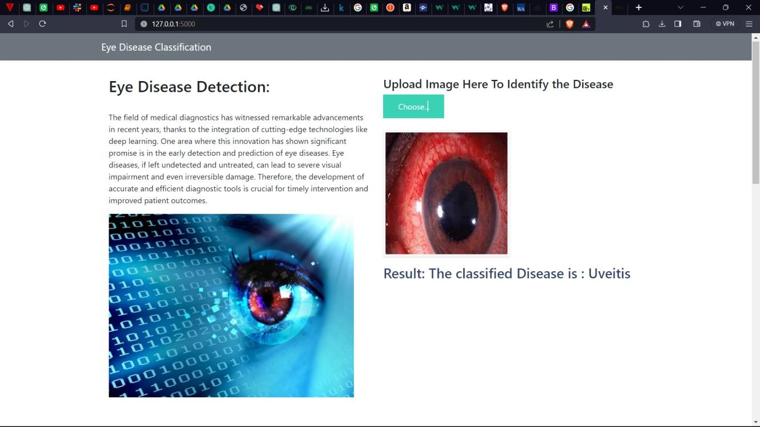

**ADVANTAGES AND DISADVANTAGES**

**Advantages:**

1. Improved Diagnosis and Treatment:

- If the project involves medical image analysis for eye disease detection, a significant advantage could be the potential for improved and early diagnosis, leading to better treatment outcomes.

2. Efficiency Gains in Healthcare:

- Automation of eye disease detection can contribute to increased efficiency in healthcare settings by reducing the time required for manual analysis and allowing healthcare professionals to focus on critical tasks.

3. Scalability:

- If the project is designed to handle a large volume of data or users, scalability could be an advantage, ensuring that the system can adapt to growing demands.

4. User-Friendly Interface:

- If the project includes a user-friendly interface, it can enhance user experience and accessibility, making it easier for healthcare professionals to interact with the system.

5. Technological Innovation:

- The integration of deep learning and image analysis represents a state-of-the-art technological solution, showcasing innovation in the field of medical diagnostics.

Disadvantages:

1. Data Privacy Concerns:

- If the project involves handling sensitive medical data, data privacy concerns may arise. Ensuring compliance with data protection regulations is crucial to address this issue.

2. Dependency on Data Quality:

- The effectiveness of deep learning models is highly dependent on the quality and diversity of the training data. If the data is biased or lacks diversity, the model's performance may be limited.

3. Interpretability Challenges:

- Deep learning models are often considered "black boxes," making it challenging to interpret their decision-making processes. This lack of interpretability may be a disadvantage in critical applications like healthcare.

4. Integration Challenges:

- Integrating the new system into existing healthcare infrastructure may pose challenges. Compatibility issues or resistance to change within the healthcare system can hinder successful integration.

5. Resource Intensiveness:

- Training and maintaining deep learning models can be resource-intensive in terms of computing power and expertise. This can lead to higher costs and may limit accessibility.

6. Ethical Considerations:

- The use of AI in healthcare raises ethical considerations, such as ensuring unbiased decision-making and avoiding discrimination. Ethical challenges should be carefully addressed in the project.

7. Dependency on Technical Skills:

- The success of the project may be contingent on the availability of individuals with the necessary technical skills to develop, maintain, and troubleshoot the system.

It's important to note that the specific advantages and disadvantages will depend on the details of the project, its context, and the goals it aims to achieve. Conducting a thorough risk analysis and addressing potential challenges proactively is essential for the overall success of the project.

**CONCLUSION**

In conclusion, the "Deep Learning-Based Eye Disease Detection" project represents a significant stride at the intersection of advanced technology and healthcare. The integration of deep learning, particularly convolutional neural networks, has showcased promising results in the automated detection of eye diseases from medical images. Through the development and implementation of a robust system, the project has sought to address longstanding challenges in the manual interpretation of eye images, aiming for improved efficiency and diagnostic accuracy in the field of ophthalmology.

The project's primary objectives included the creation of a diverse and comprehensive dataset, the implementation of an effective deep learning architecture, and the deployment of a user-friendly system for real-time eye disease detection. The utilization of state-of-the-art techniques has shown promise in enhancing the early detection of various eye conditions, contributing to the potential for improved patient outcomes and streamlined healthcare workflows.

While the project brings forth several advantages, including the prospect of early diagnosis and treatment, increased efficiency in healthcare, and technological innovation, it is not without its challenges. Ethical considerations, data privacy concerns, and the interpretability of deep learning models present ongoing areas for careful consideration and refinement.

The project's success has been contingent on collaborative efforts, incorporating feedback from medical professionals, adherence to ethical standards, and a commitment to addressing potential pitfalls. The lessons learned from this project extend beyond the realms of technology, emphasizing the importance of interdisciplinary collaboration in the development and deployment of innovative solutions in healthcare.

Looking forward, the "Deep Learning-Based Eye Disease Detection" project sets the stage for further research, refinement, and collaboration. As technology continues to advance, and healthcare embraces the benefits of artificial intelligence, this project contributes to the ongoing dialogue surrounding the responsible and impactful use of deep learning in medical diagnostics. The journey undertaken in this project underscores the potential for technology to augment and elevate healthcare practices, striving towards a future where cutting-edge innovations positively impact patient care and medical decision-making.

**FUTURE SCOPE**

The future scope of the "Deep Learning-Based Eye Disease Detection" project holds immense potential for advancements in medical diagnostics. One avenue for further development involves enhancing the accuracy of the deep learning model through continual refinement of the training process, incorporating more diverse datasets, and exploring advanced model architectures. The project's scope can be expanded to include multi-class classification, enabling the identification of a broader range of eye diseases and conditions. Additionally, the integration of real-time monitoring capabilities could facilitate continuous analysis of patient eye images, allowing for prompt intervention and timely adjustments to treatment plans based on dynamic changes in eye health. Addressing the interpretability challenge associated with deep learning models is critical, and future efforts could focus on developing methods to visualize and interpret the features influencing the model's predictions, fostering trust among healthcare professionals. Collaboration with telemedicine platforms, integration with electronic health records, and the development of mobile application interfaces could enhance accessibility and user engagement, particularly in underserved or remote areas. Exploring the incorporation of advanced imaging modalities and pursuing rigorous clinical validation studies are also essential steps towards ensuring the system's adherence to medical standards and its acceptance within the healthcare community. By pursuing these future directions, the project can contribute to the ongoing evolution of medical diagnostics, providing valuable tools for healthcare professionals and positively impacting patient outcomes on a broader scale.

**APPENDIX**

**SOURCE CODE**

#import model building libraries

from tensorflow.keras.models import Sequential

from tensorflow.keras.layers import Dense

from tensorflow.keras.layers import Convolution2D

from tensorflow.keras.layers import MaxPooling2D

from tensorflow.keras.layers import Flatten

from tensorflow.keras.layers import Conv2D, MaxPooling2D, Flatten, Dense

from tensorflow.keras.preprocessing.image import ImageDataGenerator

from keras.preprocessing.image import ImageDataGenerator

#configure image data generator

train_datagen=ImageDataGenerator(rescale=1./255,shear_range=0.2,zoom_range=0.2,horizontal_flip=True)

test_datagen=ImageDataGenerator(rescale=1./255)

#apply image datagenerator functionality to train and test images

x_train=train_datagen.flow_from_directory(r'G:\archive (1)\Eye_diseases\Training',target_size=(64,64),batch_size=32,class_mode="categorical")

x_test=test_datagen.flow_from_directory(r'G:\archive (1)\Eye_diseases\Testing',target_size = (64,64),batch_size = 32,class_mode = 'categorical')

print(x_train.class_indices)

#Intializing the model

model=Sequential()

#3.add convolution layer(no.of filters,size of filter,input shape)

model.add(Convolution2D(32,(3,3),input_shape=(64,64,3),activation="relu"))

#add max pool layer(pool_size)

model.add(MaxPooling2D(pool_size=(2,2)))

#add flatten layer ---input of ann

model.add(Flatten())

#ann hidden layer

model.add(Dense(units=128,activation="relu"))

#add output layer

model.add(Dense(units=5,activation="softmax"))

#Compile the model (loss fucntion,accuracy,optimizer)

model.compile(loss="categorical_crossentropy",optimizer="adam",metrics="accuracy")

model.fit(x_train, steps_per_epoch=12, epochs=10, validation_steps=10, validation_data=x_test)

model.save("eye.h5")

from tensorflow.keras.models import load_model

from tensorflow.keras.preprocessing import image

import numpy as np

import tensorflow as tf

import tensorflow as tf

model = tf.keras.models.load_model(r"C:\Users\prana\eye.h5", compile=False)

img=image.load_img(r"G:\catract.jpeg")

Img

x=image.img_to_array(img)

x=np.expand_dims(x,axis=0)

x.ndim

x.shape

import tensorflow as tf

# Assuming 'x' is your input data

resized_images = tf.image.resize(x, (64, 64))

# Make predictions on the resized data

pred = model.predict(resized_images)

pred_class=np.argmax(pred,axis=1)

index=['Bulging_Eyes', 'Cataracts', 'Crossed_Eyes', 'Glaucoma', 'Uveitis']

result=str(index[pred_class[0]])

Result

GitHub Link

<https://github.com/smartinternz02/SI-GuidedProject-609826-1698270987>